1

1

1

∞

**3rd Party Parts**

Vendor Name (PK)

Compatible Game (FK)

Website

Type

Scale

Notes

**Faction Info**

Faction ID (PK)

Army

MegaFaction

Faction

Subfaction

Game Name (FK)

Owner Name F

Owner Name L

**Game Info**

Game Name (PK)

Manufacturer

Website

Type

Scale

Play Area

**Model Info**

Model ID (PK)

Model

Unit Name (FK)

Faction ID (FK)

Material

Name

Assembled

Painted

Magnetized

Model gear 1

Model gear 2

Model gear 3

Model gear 4

Model gear 5

Distinguishing features

Model Notes

∞

∞

∞

**Boxes**

ID (PK)

Unit Name (FK)

Box name

Manufacturer Website URL

Price

SKU

**Unit Info**

Unit Name (PK)

**Unit Type (FK)**

Unit Min Size

Unit Max Size

Unit Composition

**Unit Type Info**

**Unit Type (PK)**

Game_Name (FK)

Description

1

**1**

1

∞

∞

∞

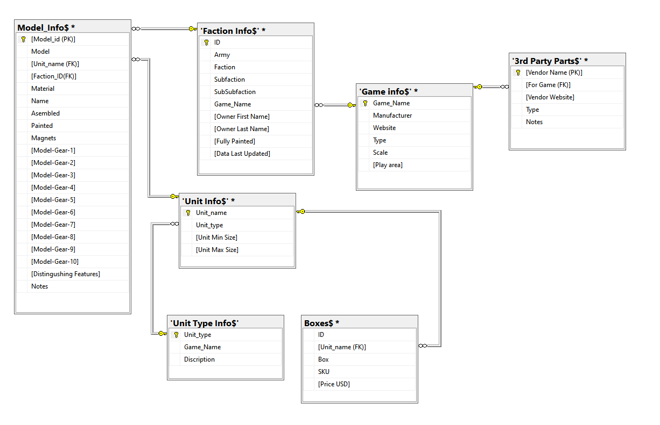WIP SQL Server Diagram